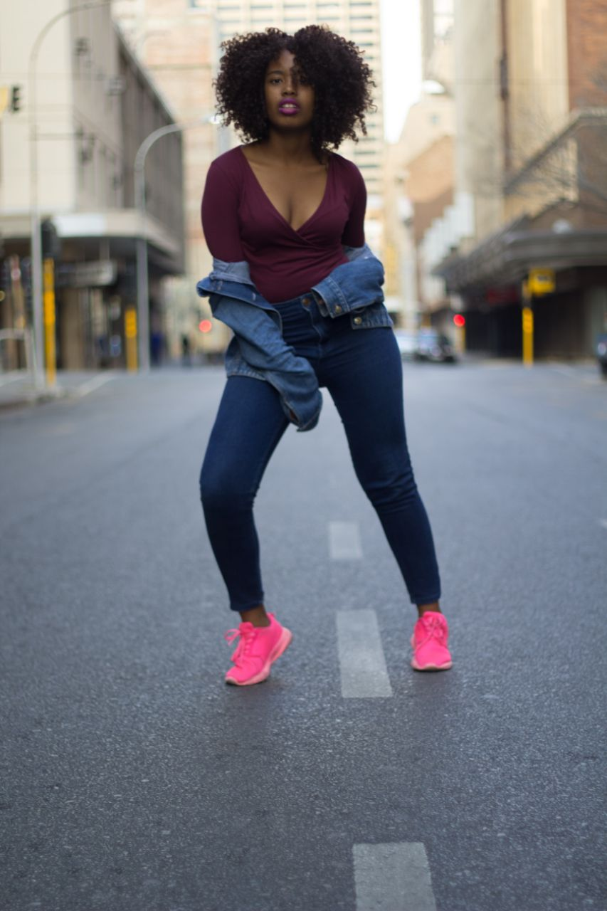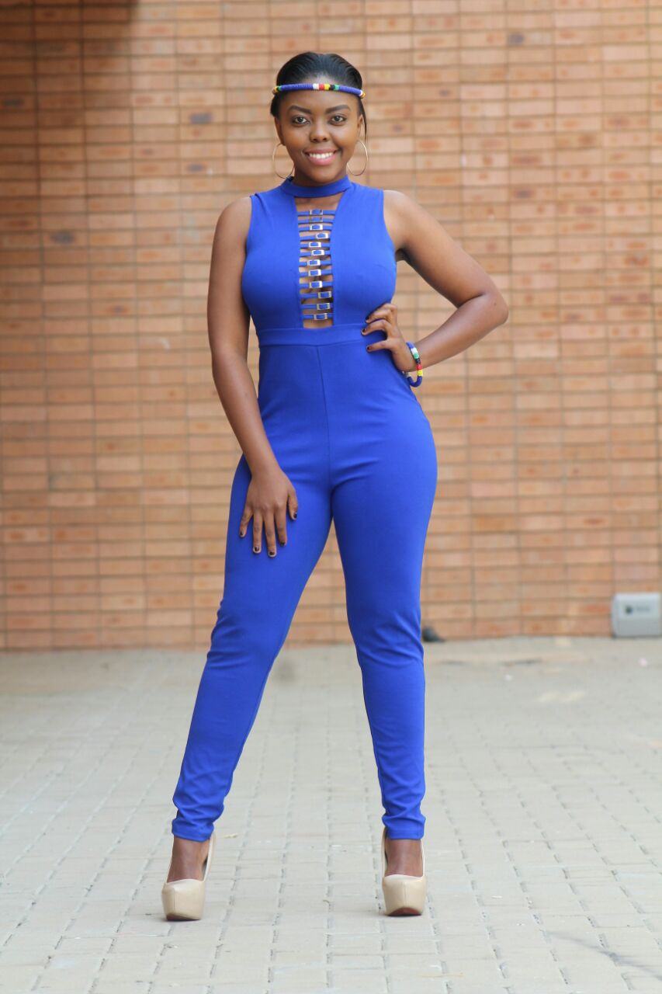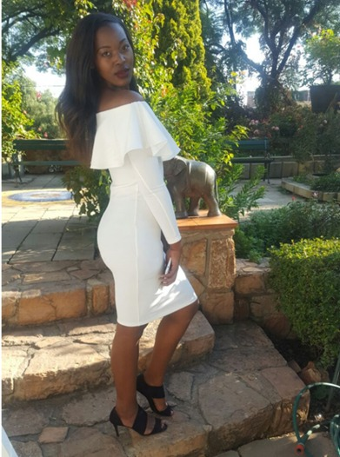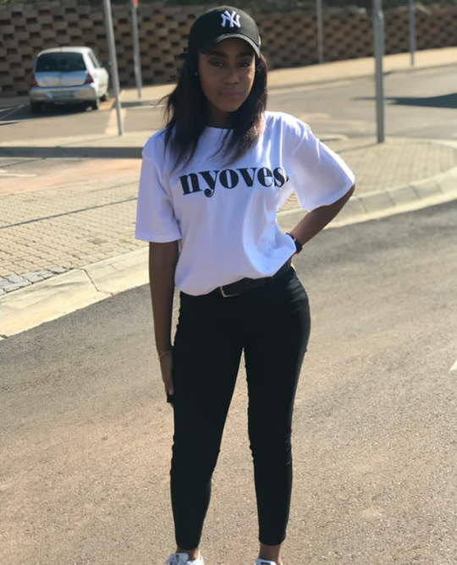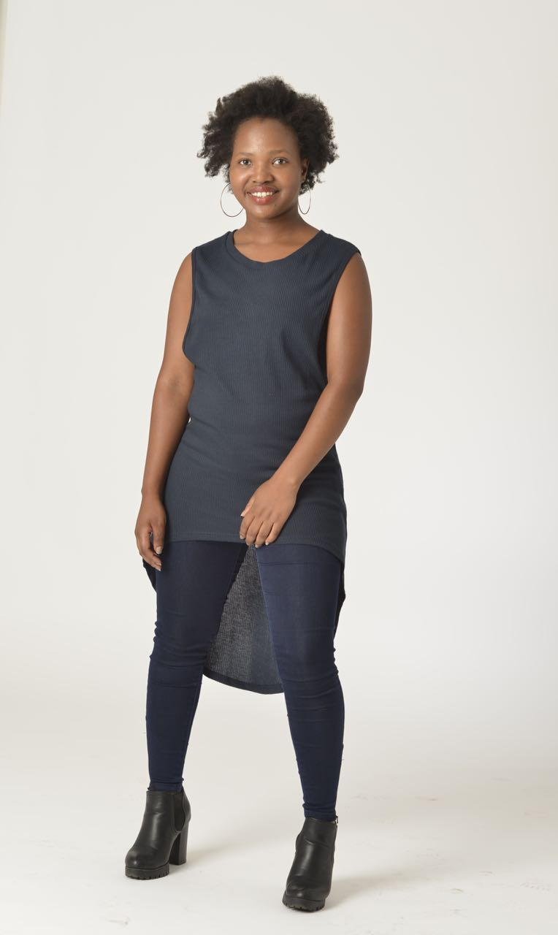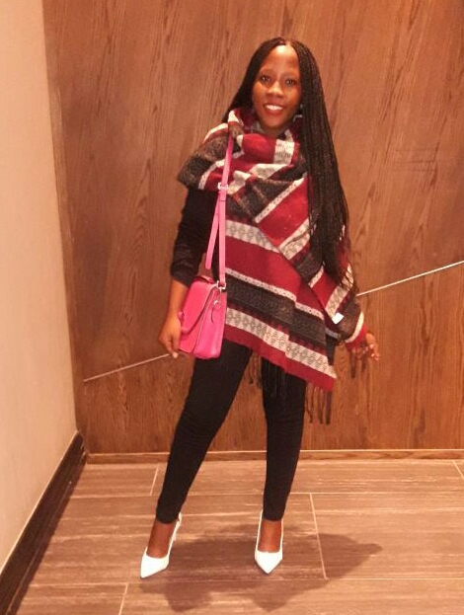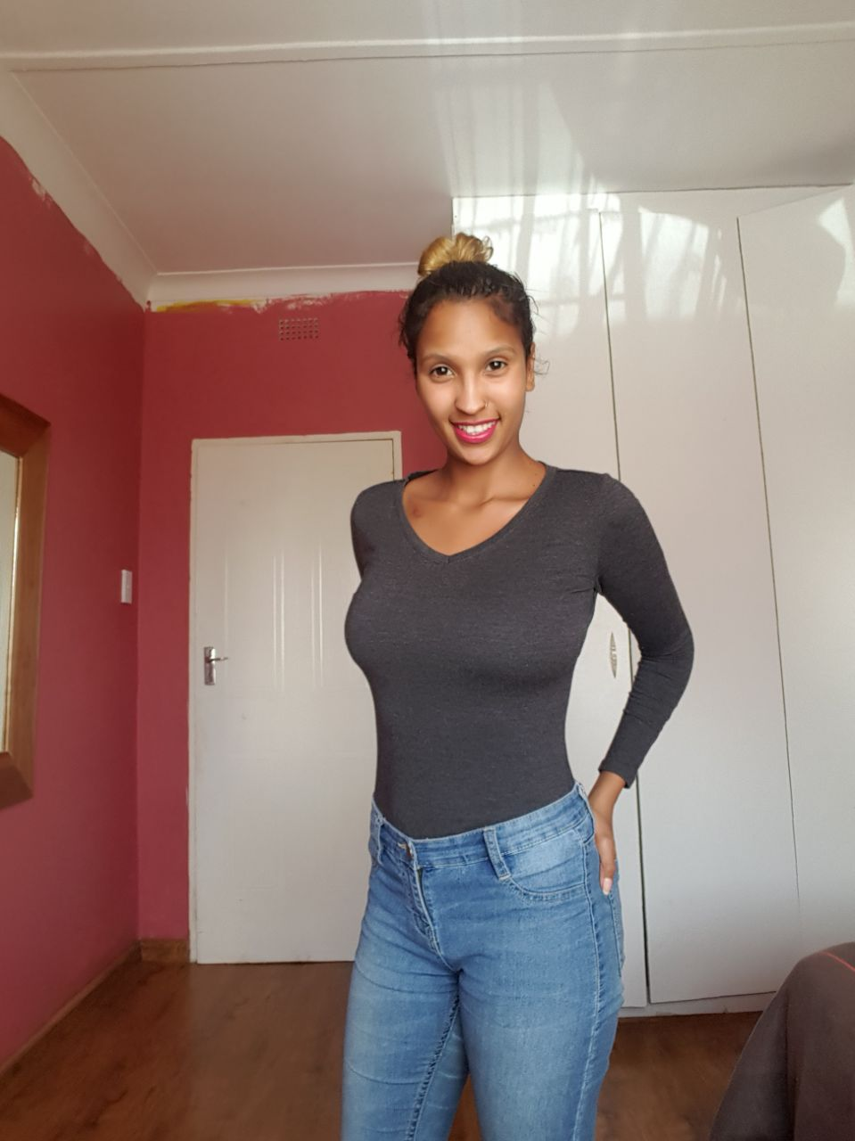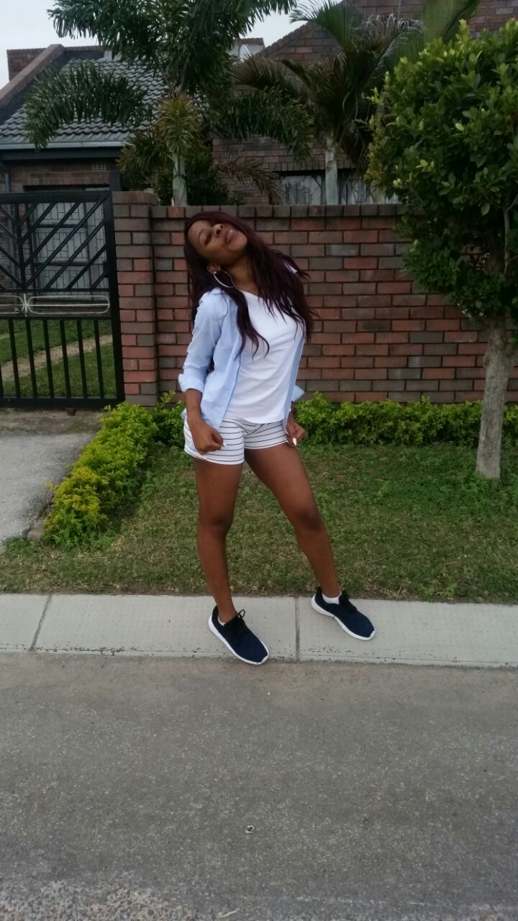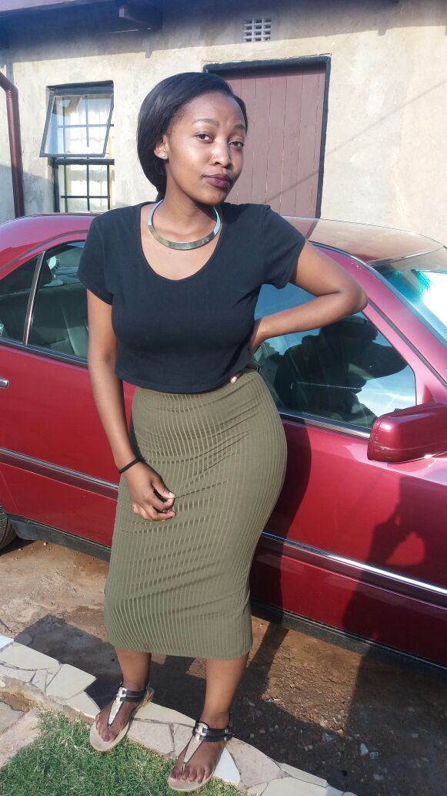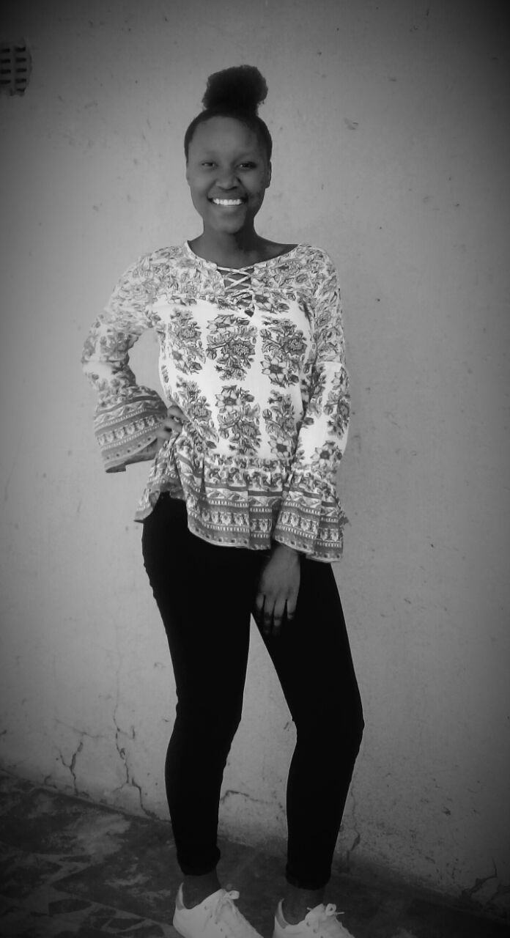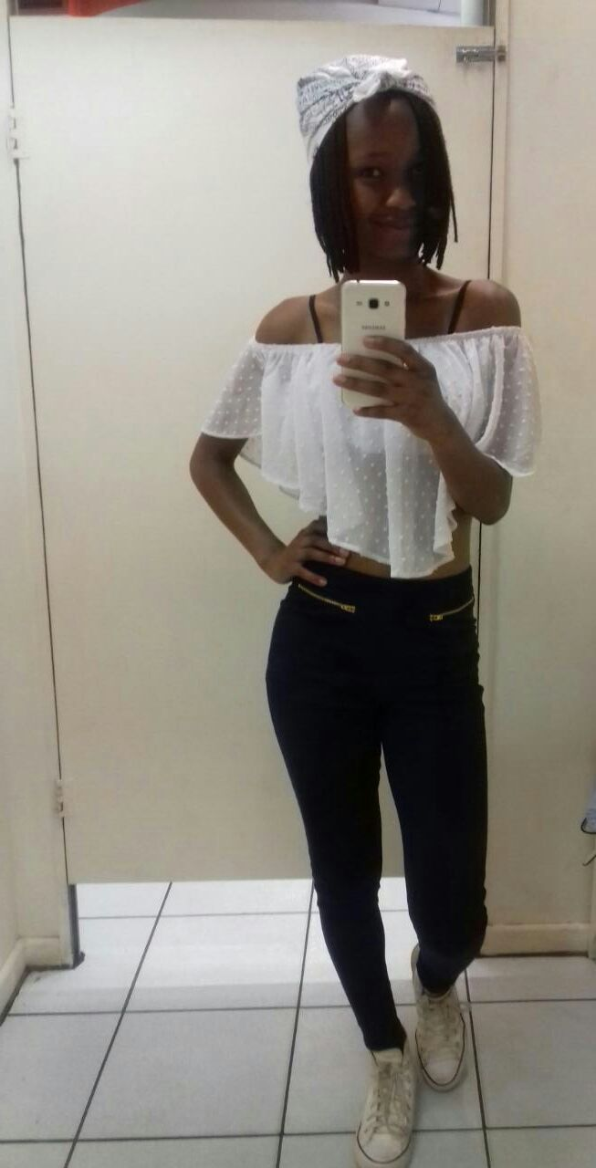

Boitshepo Masemola

Contact numbers: 084 399 1183

SIZES

Dress: 32

T-shirt: small

Pants: 34

Shoes: 4

Mamello Makhanya

Contact numbers: 0812577104

SIZES

Dress: 34

T-shirt: medium

Pants: 34

Shoes: 5

Mpho Mosalakae

Contact numbers: 074 212 7621

SIZES

Dress: 32

T-shirt: small

Pants: 32

Shoes: 7

Masoko Makoae

Contact numbers: 0643956717

SIZES

Dress: 30

T-shirt: small

Pants: 32

Shoes: 5

Valentine Ndlovu

Contact numbers: 083 496 7197

SIZES

Dress: 34

T-shirt: small

Pants: 34

Shoes: 4

Thabiso Mogwasa

Contact numbers: 078 907 4660

SIZES

Dress: 30

T-shirt: small

Pants: 30

Shoes: 4

Sherees Martlouw

Contact numbers: 061 098 5875

SIZES

Dress: 32

T-shirt: small

Pants: 32

Shoes: 4

Lebohang Mngwenya

Contact numbers: 072 498 2210

SIZES

Dress: 32

T-shirt: 28

Pants: 32

Shoes: 7

Refiloe Ramodike

Contact numbers: 062 094 1344

SIZES

Dress: 30

T-shirt: small

Pants: 32

Shoes: 4

Jabulile Mdumbe

Contact numbers: 074 952 9522

SIZES

Dress:

T-shirt:

Pants:

Shoes:

Bianca Skhosana

Contact numbers: 084 803 840

SIZES

Dress: 28

T-shirt: small

Pants: 30

Shoes: 5

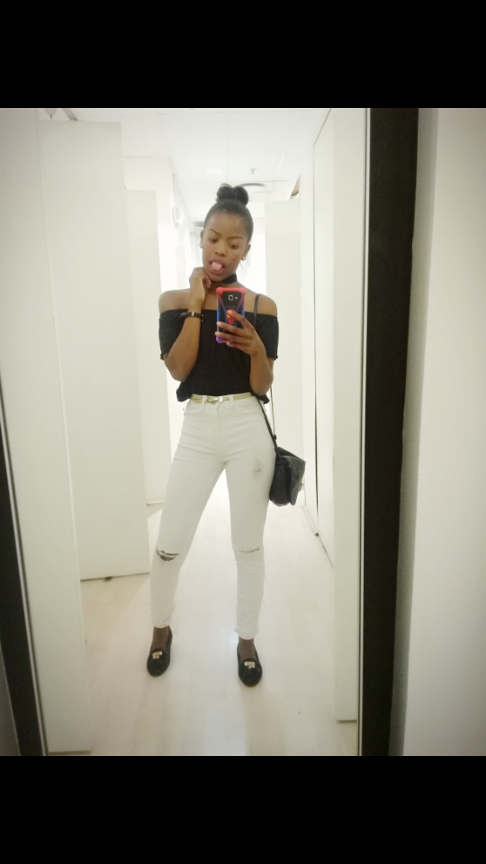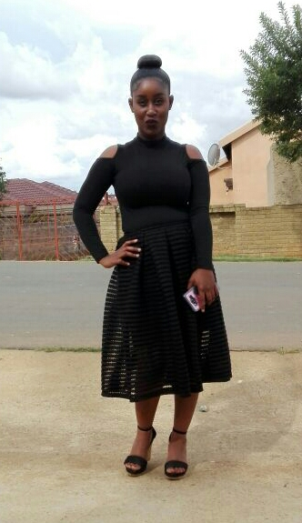

Tshegofatso Mashamaite

Contact numbers: 064 079 2874

SIZES

Dress: 28

T-shirt: small

Pants: 28

Shoes: 3

Boitumelo Sibisi

Contact numbers: 062 540 3362

SIZES

Dress: 34

T-shirt: medium

Pants: 34

Shoes: 5

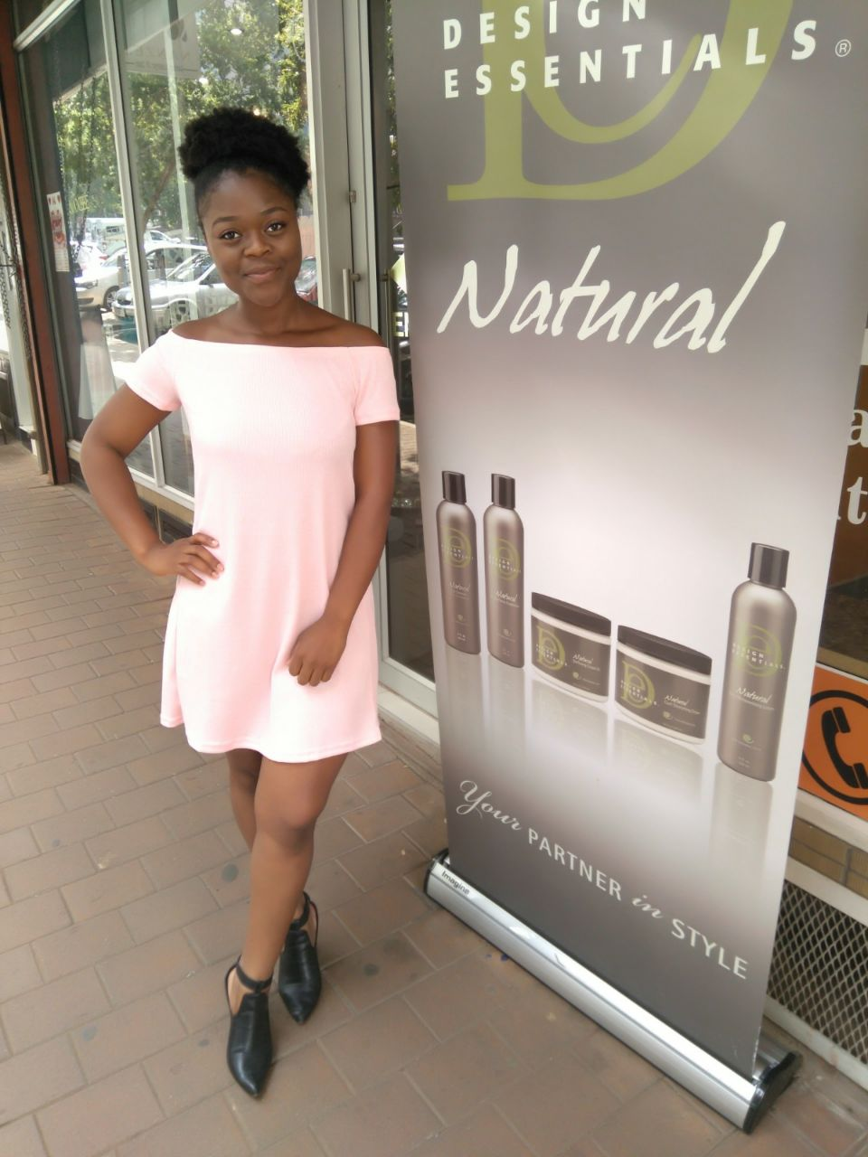

Londiwe Sibanda

Contact numbers: 079 227 4281

SIZES

Dress: 32

T-shirt: small

Pants: 34

Shoes: 5